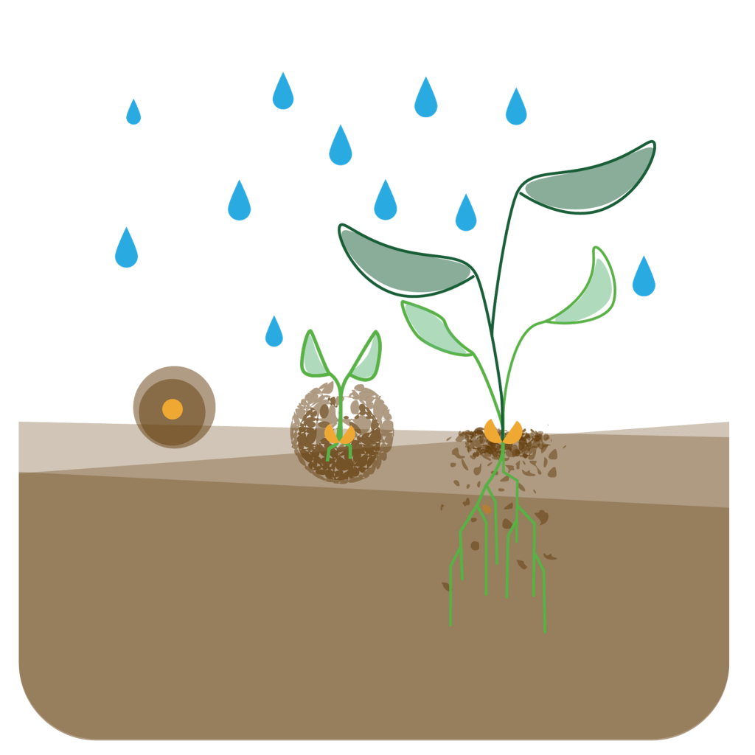
Seedballs Brief Technical Guideline

Contents
History 3
Physics 3
Seed Collection 3
How to make seedballs 4
Aerial seeding 6
Precautions 7
Monitoring 7

History
Seed balls, earth balls or seed “bombs”, whatever you want to call them, are an easy way for folks of all ages to influence the landscape around them in a safe and environmentally friendly way. Seeds balls are designed using natural ingredients to encase and protect the seeds within, so they don’t dry out or get snapped up by birds before they have a chance to germinate. Seed balls require only a few easily accessible ingredients to make and are super-simple to put together. The shelf-life of seed balls make them the perfect rainy-day activity for your class or kids at home and can be saved up for that perfect planting or throwing in Fall or Spring. Through much experimentation, wonderful uses and benefits of seed balls can be summarized:
- Vegetable and cover crops
- Supporting pollinators, bees, butterflies, and birds
- Nourishing seeds and soil
- Reducing daily watering during spring
- Protecting seeds from birds and squirrels
- Fun as an activity for all ages
- Ecological restoration of dry and degraded areas

Physics
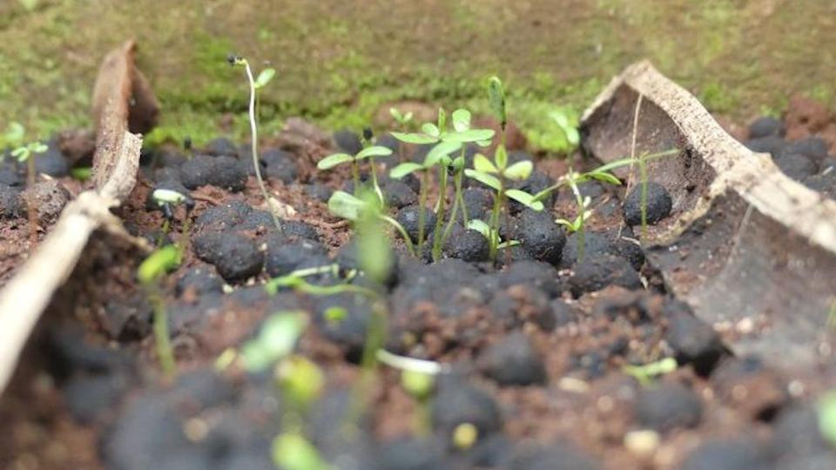
Seed balls are easy to distribute quickly over distances. They can be thrown or partially planted. Seed Balls commonly have organic matter that helps hold the seed balls together upon impact and ensuring nutrients when germinating. The areas where seed balls are thrown can have several surface conditions, the surface can be dry, overly hot, or cold and windy, making life hard on a germinating seed. The clay and organic matter in seedballs has very high surface areas and holds a lot of water. This helps retain moisture, facilitating germination and growth of the seedlings and have low cost compared to plantation.

Seed Collection
Seeds should be collected based on their specific season of occurrence in nature. (for more information check: https://www.lri-lb.org/resources-and-publications-details/12). The Aim of seed balls is to increase the vegetation cover of native species. Thus, native species in the target area must be identified and set a clear schedule for seed collection time.
The seeds are to be completely dried without having any amount of moisture. Once the rainy season is about it arrive that when the seed balls are to be prepared.
Pick a seed that is easy to germinate with little or no stratification need and that is native to the area and known to withstand drought. The objective of seed balls is to have a cost-effective restoration method and does not include irrigation, it is important to select seeds that would not need irrigation to ensure survival.
It is good to think like a tree, look for pro-active microhabitats for your seed balls. Favor areas likely to conserve moisture and places wildlife and livestock can’t access easily. Do your best to match plant and tree species to their natural environmental types.
Note that if seed balls are thrown in areas where there is insufficient water, light, and no obvious soil for the plants to anchor themselves, the seed balls will perish.

How to make seedballs
In this document one method will be adopted for making seed balls, knowing worldwide you can do seed balls in many ways.
The adopted method includes 5 keys elements.
- Soil: Usually is clay, its role is to give the seedballs its texture and protects it from environmental conditions.
- Compost: Compost is to hold moisture and nutrients that will support the seeds once they germinate
- Seeds: Seeds of native species that will germinate in the right conditions
- Natural repellents: black pepper to protect from rodents and insects playing the role of natural repellents.
- Water: Water is used to mix clay compost and insert the seeds within the seed balls

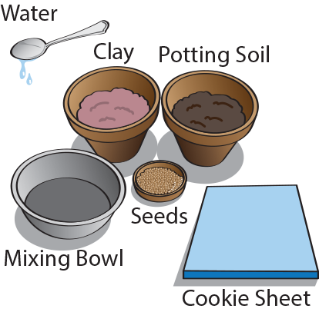
Start by mixing Equal volume of soil (clay) and compost and sufficient amount of water. Use enough water to make the seed balls texture stable. The soil should not be wet as it might germinate the seed. Dry soil must be used while making the seed ball required amount of water can be added. The seed ball should not sow inside the soil it should be only partially sown if going for sowing of them. Apart from that just throwing them will also be sufficient.

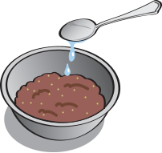
Usually you can use 5 cups of compost and 5 cups of clay, adding to them 1 cup of seeds. Then add water and mix the ingredients. In case the seed size in medium to big, do the mixture without adding the seeds, then at the end insert the seeds.

Preferable of each seed ball to have 3-5 seeds at least to ensure high germinate rate. the seed balls size is between 3 to 5 centimeter diameter. While making the seed balls the consistency of the soil should be smooth, it should be sieved before using it.

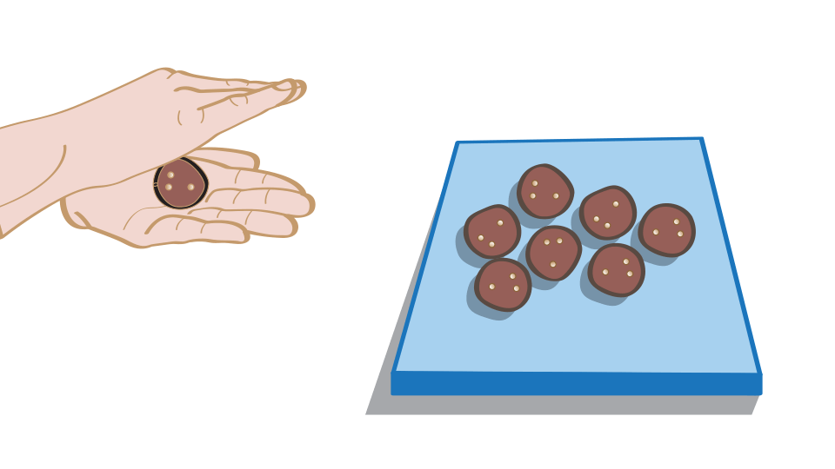

After the seed balls have been formed they must dry for 24 to 48 hours befre use. Not in the sun – off shade.
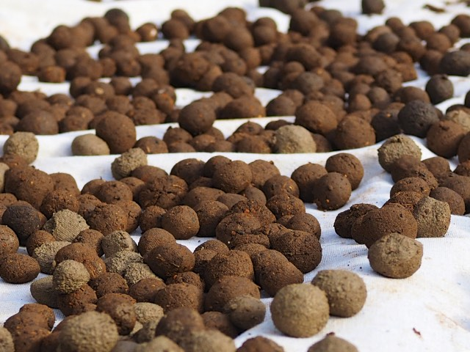

Aerial seeding
Aerial seeding is therefore best suited to sites whose remoteness, ruggedness, inaccessibility, or sparse population make seedlings planting difficult. It is particularly appropriate for “Protection forests” because helicopters or planes can easily spread seed over steep slopes or remote watersheds and isolated dryland areas. It seems also well suited for use in areas where there may be a dearth of skilled laborers supervisors and funds for reforestation.

Precautions
Seed balls making and usage does not go without certain risks and notions to take into consideration to ensure higher success rate:
- To remove excess moisture, adding compost can absorb the excess water and prevent the early germination of seed in the seed ball itself.
- The characteristic of the species especially the ability of its seed to germinate should be kept in mind.
- Different types of seed may be combined but check that they can all be sown at the same time of the year and have similar light and soil Requirements.
- Direct seeding trials should first be implemented at sites favorable for seeding and then with experience should move to the more difficult sites.
- Along with all direct seeding trails should be some seedlings planting trials. The relative costs and successes of the two techniques can be better judged when they done in tandem.
- Contrary to popular belief, seeds bombs are not meant to be buried in the ground. Instead, embed them partially in the ground.

Monitoring
It is important to track in quantitative and qualitative the performance on the seed balls.
Thus, developing a monitoring protocol on small scale for seed balls different species and location to be used is better to be tested.
For seed balls, a basic monitoring protocol can be used in any area before major intervention:
- Select a location
- Take GPS point of the location
- Clean the area (3 x 3) from weeds and other vegetation
- Throw 100 seedballs
- Monitor monthly:
  - Germination rate
  - Survival rate
- The monitoring time frame is best to be for at least 1 year to be able to track seed balls survival rate

